COMP304 Marta Polishchuk - 301432299 Midterm Screenshots
Home Screen
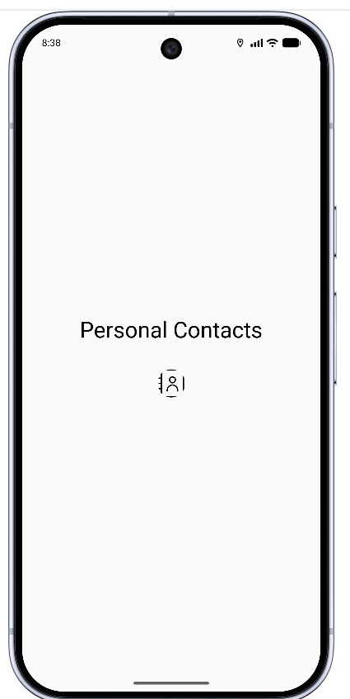
Contact List Screen (empty)
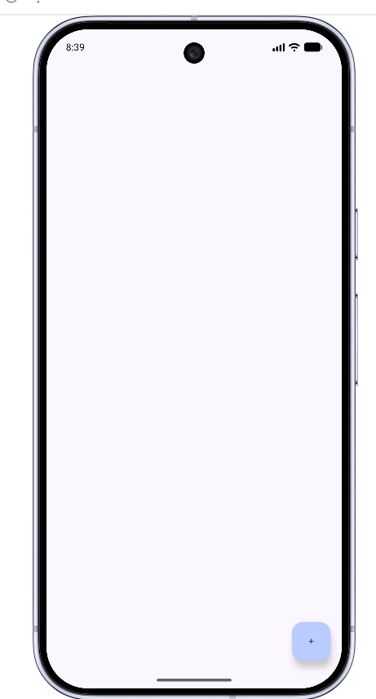
Add Contact Screen
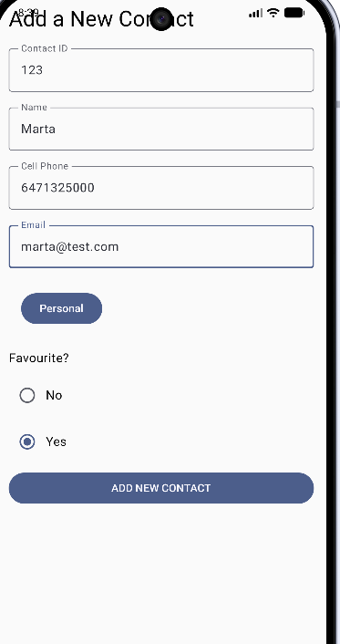
Contact List Screen after Adding Contact
